LOW VACUUM ELECTRIC SUCTION UNIT Operating Manual

MODEL DYX-2A

GENERAL
LOW VACUUM ELECTRIC SUCTION UNIT model DYX-2A is the latest portable Low Vacuum and Low Flow suction unit. It is suitable for postoperative continuous drainage in gastroenteric, thoracic and celiac cavity or in the Dept.of surgery and internal medicine.
- The unit is 220V AC mains operated. It is a ClassⅡType B Electrical Medical Device and complies to IEC601-1:1988, Safety Standard.
- LOW VACUUM ELECTRIC SUCTION UNIT model DYX-2A is medical suction. And according to MDD (93/42 EEC) ANNEX Ⅸ CLASSIFICATION CRITERIA, the classification of it is CLASS Ⅱa.

SAFETY PRECAUTIONS
- The working of the unit is continuous operation;
- Please avoid using the unit near any flammable and /or volatile agents;
- The packed aspirators should be kept indoor with no corrosive gas and well ventilated;
- Don’t suction flammable, highly volatile liquid or gases;
- Disinfecting or sterilizing should comply with the method recommended by the manufacturer or comply with the relevant regulations of hospitals.
- Forbid laying the equipment into water or other liquid;
- The equipment should be operated with Air Filter and suction hose. Don’t connect the catheter directly to the bottle’s patient joint, which marked “IN”;
- Before connecting the unit to the mains supply, please ensure that the voltage of the unit should be consistent with that of the mains supply;
- Before operating, please test the function of this unit. If there is any doubt about the operation of this unit, please get in touch with supplier or manufacturer.
Warning: Don’t open the electrical equipment for any reason. If the equipment fails to operate, you must contact the manufacturer or agent for service recommendations. The equipment must only be opened by a service engineer or by qualified personnel.

FUNCTIONS AND OPERATIONAL PRINCIPLE
- An electromagnetic pump provided for LOW VACUUM ELECTRIC SUCTION UNIT model DYX-2A acts as the vacuum source with low noise and needs no lubrication or daily maintenance. It can provide a protection for the environment. No positive pressure in the working system makes it safe and reliable to operate;
- Air Filter provides an effective barrier against contamination and protection to the environment;
- The overflow protection device is intended to prevent liquid or solid particles from entering into the intermediate tubing.
- Vacuum regulator with a locked set can be step-less regulated by the vacuum regulator according to the clinical requirement.
- The vacuum gauge can display the current vacuum value;
- Equipped with a cleaning-cuvette which can reduce the probability of cross infection.
- The case and the bottle made of plastic material are light, compact, and convenient for carrying and operating.

CONSIGNMENT
- The unit has been strictly inspected and carefully packed before it was consigned;
- Before assembling and calibrating, please inspect the surface of the unit and the kinds and quantities of the accessories according to the parts list. Please contact the supplier or manufacturer in time if there are any problems.

LEGEND
Attention of the documents!

ClassⅡ－the classification of electrical protection

Type B—the degree of protection against electric shock

Big and small arrow (Increasing or decreasing the vacuum)

INSPECTION AND ASSEMBLY
Vacuum Joint,
marked ‘OUT’
Air Filter
Suction Tubing
Lid Agraffe
Suction Hose

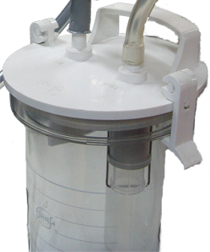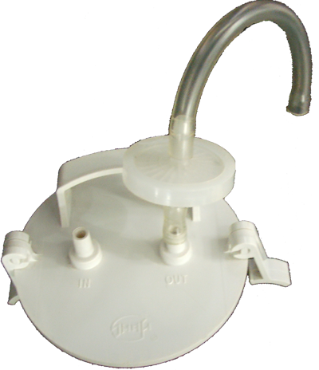
IN
OUT
Fig.1 Construction of the storage bottle
Patient Joint,
marked ‘IN’

Overflow Protection Device
Bottle Lid
Storage Bottle

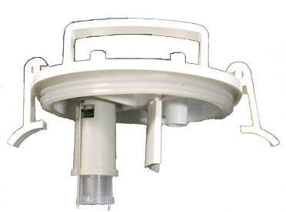

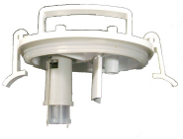
Fig.2 Bottle Lid

- Construction of the Storage Bottle (see Fig.1)
- Disengaging the Overflow Protection Device from the Bottle Lid (see Fig.2)
Undo the Lid Agraffe and open the Bottle Lid with Overflow Protection Device, turn the Overflow Protection Device anti-clockwise until it is disengaged from the Lid.
- Inspect and test overflow protection device
- Pinch the Metal Fastener of the Overflow Protection Device and turn it along the arrow with exertion until the Metal Fastener slips out of the groove of the Float frame (see Fig.4);
- Take the Float out of the Float Frame along the arrow (see Fig.5);
- Inspect the Rubber Valve Vane for warp or tear and other damage. And ensure that the Rubber Valve Vane should be connected well to the Float, and then clean the entrance of the valve and the Rubber Valve Vane (see Fig.6);
- Re-assemble the Overflow Protection Device in the reverse order and the float should move up and down freely in the Float Frame along the arrow (see Fig.3);
- Re-connect the Overflow Protection Device to the Bottle Lid;
- Held the Lid, make the Float vertically come into the water surface, the Float should float up along with the Float Frame as the Lid goes down slowly.
- Press the Lid tightly, then connect the Suction Hose to the “IN” inlet of the Storage bottle, and run the equipment with the regulator tightened clockwise.
- Immerse the suction hose into a clean water container, or suck some water into the Storage bottle as if it is working in normal use. Aspiration should be stopped when water has reached to the level that the float valve could shut off the vacuum supply to the Storage Bottle. Different application in suction shall result in variety of the final liquid level.
- Screw the vacuum regulator anti-clockwise, shut off the unit switch, open the Bottle Lid, and empty the Storage bottle. Re-assemble the lid tightly, and the Float should be located at the bottom of the overflow float frame with the valve entrance open.
Corresponding to the condition above, it is proved that the Overflow Protection Device is effective.
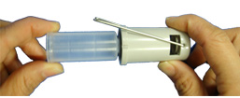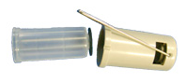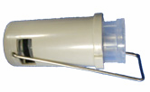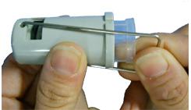
Metal Fastener
Fig.5
Fig.4
Float Frame
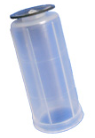
Rubber Valve Vane
Float

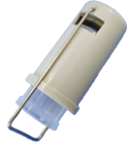
Fig.3

Fig.6

Note 1: Two possible cases as followed shall lead the liquid level to rise continuously even the overflow protection valve has operated.① the vacuum left in the storage bottle. ② The valve entrance has not been thoroughly occluded. For the former, the liquid level shall not rise any longer when the suction hose removed from the liquid is re-inserted. For the later, special attention must be paid to this matter. When the Storage bottle is full, take the Suction Hose away from the liquid immediately, turn off the unit, and find out the reason why the Overflow Protection Device has failed.
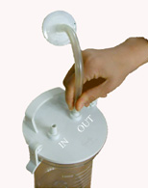Note 2: Aspiration is stopped while the Overflow Protection Device will operate shutting off the vacuum supply. But the Float is probably sucked onto the valve entrance because of the vacuum inside the supplied suction connecting tube. In this case, unscrew the vacuum regulator or shut off the equipment to release the vacuum inside the tube, and make the float fall down by gravity.
Fig.7 connect to bottle
Green dot marked
Do not pull down the Float by force to protect it against separating from Rubber Valve Vane.
Note 3: Do not open the Bottle Lid until the vacuum has released after switching off the unit
Note 4: Do not operate the apparatus without the overflow protection device and safety guard tube.

- Connect the Air Filter to the Storage Bottle (see Fig.7)
Connect two suction tubing to the Air Filter, and then connect the other end of one of the suction tubing to the “OUT” connector on the Bottle Lid.
Please ensure that the inlet of Air Filter marked green dot should be connected to the “OUT” connector on the Bottle Lid.
- Connect the Storage Bottle to the Equipment
Please hang the bottle on the equipment and then connect the other end of suction tubing connected to the filter to the connector on the equipment.
Fig.8 Verify pipeline

OPERATION
          - Connect to mains supply
Before connecting the unit to the mains supply, please ensure that the voltage of the unit should be consistent with that of the mains supply and the switch is in the “OFF” position. And when inserting the plug into the mains supply socket, the indicator LED illuminates.
The device that separates the unit from the mains supply is the plug of power cord.

          - Verify pipeline(see Fig.8)
Switch ON the switch to start the unit with the inlet on the Bottle lid occluded. Pull out the vacuum regulator knob, and turn the control valve clockwise or anti-clockwise. To increase the suction, please turn the regulator clockwise and the vacuum gauge will vary from 2kPa (15mmHg) to max.vacuum. To decrease the suction, turn the regulator anti-clockwise. When the required vacuum is displayed on the vacuum gauge, push the vacuum regulator knob into the locked position.
Corresponding to the conditions above indicates that the pipeline is correctly connected and the unit is well.
The principle of the locked set of this vacuum regulator is a push-and-pull device. Before screwing the vacuum regulator knob, you should pull it out. Avoid from damage, don’t screw it as it is on the locked state

          - Operation
            - 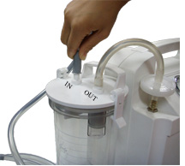 Before use, inspect the apparatus according to the procedure of assembly, and ensure that your suction unit is in kilter. Turn the vacuum regulator clockwise or anti-clockwise until the clinical requirement is obtained (see Fig.8).
Fig.9 connect suction hose
            - Connect one end of the sterilized suction hose to the inlet of the Storage bottle and then connect the required catheter to the other end of the sterilized suction hose (see Fig.9 and 10). Now it is ready for operation.
- Before stop working, sucking a little clean water will be helpful to make suction hose clean.

- Usage of the cleaning-cuvette
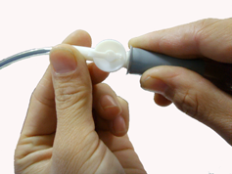Usually, some disinfectant solution can place in the cleaning- cuvette, which is used for placing catheter before or after operation.
Fig.11 connect the catheter

- Stop Working
After adjustment or operation, please switch OFF and then pull out the plug from the mains socket to cut off the mains supply.

- Cleansing, Disinfection And Maintenance
• After stop working, put out the Suction Hose and Tubing, remove the Bottle with Lid carefully from the retaining nest and dispose of the contents appropriately. The unit and parts used should be cleaned and disinfect, referring to the list below.

Parts | Rinsing | Disinfection | Sterilization
Storage Bottle | Mix some household cleaning agent into warm water, and then clean them carefully | Immerse them in Kangweida disinfectant solution (referring to its instructions), for an hour, and then rinse and dry them thoroughly | Sterilization at 121℃ for 20 min
Cleaning- cuvette
Bottle Lid |  |  | Inapplicability
Overflow Protection Device
Suction Hose
Suction Tubing
The case | Please wipe it with some cloth sodden with disinfector. And the cloth should be squeezed so as to prevent liquid from seeping into the chinks of the case

Note 1: When rinsing or disinfection, glove is recommended (household glove or single-use glove).
Note 2: The material of the cleaning- cuvette is glass, place take it carefully when cleaning and using.
• After rinsing, disinfection and sterilization, please re-assemble the Overflow Protection Device, the Bottle Lid and the Storage Bottle in the reverse order, and then connect these Tubing and the Suction Hose correctly (referring to Ⅵ. INSPECTION AND ASSEMBLY).
Note: When operating the unit another time, the Overflow Protection Device and the Suction Tubing must be connected correctly.

- Replacement for Air Filter
• If sucks much foam or is occluded by dirt, the Air Filter diaphragms will change its color from light to dark. And the suction in the inlet will reduce or disappear while the reading shown on the vacuum gauge is rising up to more than 6kPa. Under this condition, please replace the Air Filter by a new one which is provided by the manufacturer.
• If the Air Filter is wetted or contaminated, please change it immediately.
Note1: That the Overflow Protection Device operates or the tube has been occluded will also cause the suction to reduce or disappear while the vacuum gauge reading is still rising (see item 2 in “troubleshooting”).
Note2: The used Air Filter should be disposed by the hospital according to the relevant regulations

- Replacement for fuses
When the fuses fixed on the bottom of the unit need to be replaced, cut off the power supply first, align to the cross-groove of the fuse seating with a screw-driver and screw it anti-clockwise to withdraw the seating cover, then inspect or replace the fuses.

TECHNOLOGY DATA

Item | Data | Item | Date
Type | Low vacuum/Low Flow | Electrical protection | Class Ⅱ
Max vacuum | 15kPa±1.5kPa | Degree of protection | Type B
Vacuum range | 2kPa～Max. vacuum | Medical device classification | Class Ⅱa
Suction capacity | 700mL/min (water) | Net weight | 2.5kg
Bottle capacity | 1000mL | Dimension(W×D×H) | 320mm120mm310mm
Noise | 55 dB(A) | Warranty | One year
Rated voltage | ～220V±10% 1PH | Environment in normal use | Temperature: 5~40C  Relative humidity: ≤ 80%  Atmospheric pressure: 860~1060hPa
Frequency | 50Hz
Power input | 15 VA | Environment in transport or storage | Temperature: -40~55C  Relative humidity: ≤ 95%  Atmospheric pressure: 500~1060hPa
Fuse | RF1520 0.2A/250V

TROUBLESHOOTING

Item | Fault | Cause | Solution | Remarks
1 | Max. Vacuum  <15±1.5KPa  (112±11mmHg) | 1) Leakage in the entrance of the Storage bottle  2) Leakage in the Suction tube  3) The rubber cup in the vacuum regulator is worn | Clean the entrance of the bottle and press the Bottle lid tightly  2) Reconnect the tube or replace some damaged tube  3) Replace the rubber cup in the vacuum regulator | The power supply must be cut off when the internal parts of the unit are inspected or repaired by professionals
2 | The unit fails to operate and the power indicator does not illuminate | 1) Power cut or electrical fault  2) The fuses are fusing. | 1) Examine the circuit.  2) Replace the fuses | The electrical circuit being inspected or repaired should be operated by professionals (referring to Fig .11 Circuit diagram)
3 | The vacuum gauge reading is not less than 6kPa (45mmHg) with the tube unblocked as soon as the unit is turned on. Or it reaches to the max.vacuum but the suction in the inlet reduces or disappear | - The overflow protection device operates  - The tube is occluded  - The air filter is occluded | - Turn the vacuum regulator anti-clockwise to release the vacuum, then return it clockwise  - Clean the tube or replace it  Replace the air filter by a new one | 1) Empty the Storage bottle immediately when the liquid reaches near to 1/2 capacity of it  2) The end with green dot mark of the air filter is the entrance of air flow

Note: It is recommended that the pump should be opened or repaired by professionals. If necessary, please get in touch with the manufacturer.

WASTE DISPOSAL
At the end of the useful life of the unit, all of the waste parts should be disposed according to the rules of waste disposal:
  - The storage bottle, all of the tubing, the Suction Hose and cleaning- cuvette belong to medical garbage.
  - The basic configuration of the unit can be disposed as electronic waste.
  - The material of the unit case is ABS, which can be recycled.
Fig.11 Circuit Diagram

SERVICE
- Any of our products is promised to be repaired free or replaced within one and a half years from the date of ex-factory or within one year from the date of purchasing if it is out of order. Above all, the packed unit should be stored well and operated complying with the rules recommended by the manufacturer.
- Circuit diagrams, part lists and other technical information are available upon request for qualified technical personnel.

PARTS LIST

No. | Name | Quantity
1 | Suction hose (φ5.5×8.5mm, 2m) | 1 pc
2 | Fuse (RF1 φ5×20 0.2A/250V) | 2 pc
3 | Air Filter | 2 pc
4 | 1000ml bottle (PC) | 1 pc
5 | Lid with overflow protection device | 1 pc
6 | Cleaning- cuvette | 1 pc

Design and specifications changed reserved.

